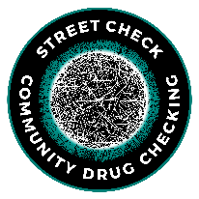

**FTIR Analysis Job Aid: “Normal” Analysis**

This document was developed by the Massachusetts Drug Supply Data Stream (MADDS). Our suggested citation for this resource is: Massachusetts Drug Supply Data Stream. (2023, July 14). FTIR Analysis Job Aid. (Massachusetts Drug Supply Data Stream, July 14, 2023). For more information, please visit our website at: streetcheck.org. To get in touch with us, please email: [madds@brandeis.edu](mailto:madds@brandeis.edu).

.

After scanning sample, OPUS will usually run a Spectrum Search automatically. If not, here’s how:



1. Click “Evaluate” → “Spectrum Search” or Click on the shortcut icon in the toolbox on the right side of the top banner. It’s a magnifying glass with small ridges/peaks inside.

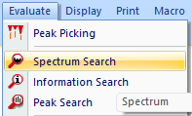

2. Once “Spectrum Search” is selected, a window will open with three tabs and make sure you have the selections you want on each one.

**Spectrum Search (see left image)**:

First tab--select which sections of the spectrum to use for the search. To start, select “Use file limits” to use the entire measured spectrum. For narrowing to a particular region of the spectrum, uncheck “Use file limits” and select the window you want.

**Search Parameters (see right image)**: Second tab--select the search algorithm to use. Normally that’s “Spectrum Correlation”, “Vector Normalization”, “1st Derivative”. If you do a mixture analysis, you can switch to that here.

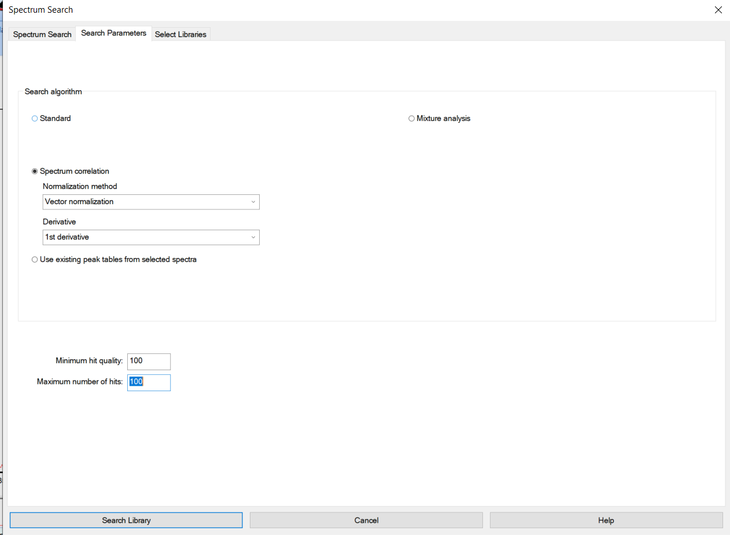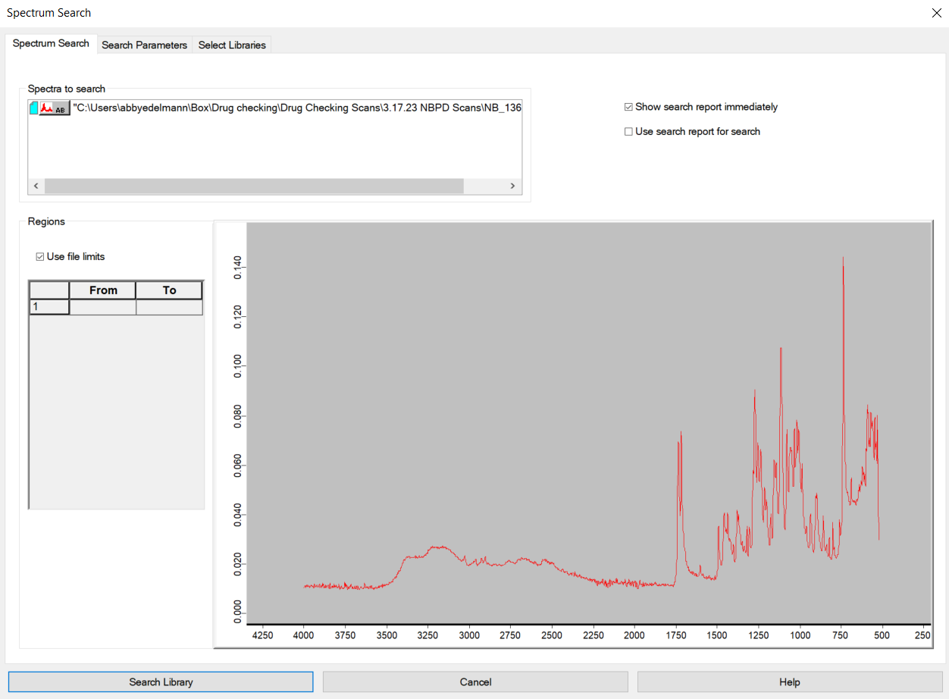

**Select Libraries**: Third tab--select the libraries to use. SWGDRUG, TICTAC ATR-FTIR, and BCCSU libraries are best. If a pill, you may want the PHARMA libraries too.

3. Click “Search Library” at bottom left of the window. Spectral matches are listed by “Hit Quality” (1000 = perfect fit of spectrum to library entry).

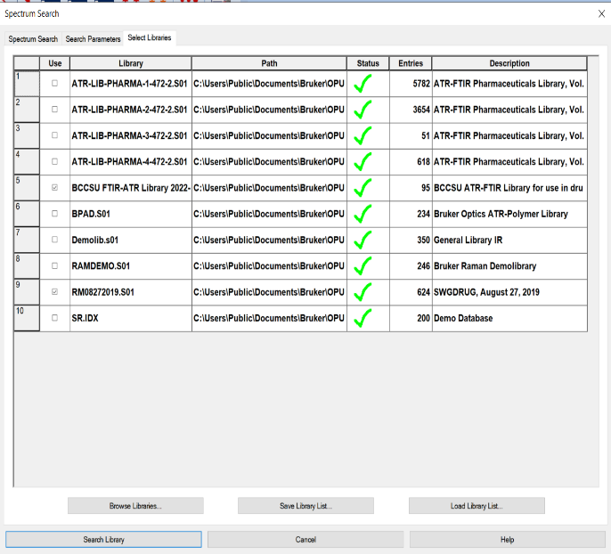

4. Review for good matches:

* >800 hit quality
* Reference--sample peak locations and relative heights align well with one another
* Reference spectrum does not have a peak that’s not accounted for in the sample spectrum (no random tall peak in reference that’s not on sample spectrum)
* For good matches on minor components: can see tallest peaks from reference spectrum on sample spectrum and these are distinguishable from the major component peak(s). Minor sample components may not match perfectly to the reference, but have tallest peaks or range of peaks (that aren’t the major components) that can be used for identification.



**FTIR Analysis Job Aid: “Auto-Subtraction”**

This document was developed by the Massachusetts Drug Supply Data Stream (MADDS). Our suggested citation for this resource is: Massachusetts Drug Supply Data Stream. (2023, July 14). FTIR Analysis Job Aid. (Massachusetts Drug Supply Data Stream, July 14, 2023). For more information, please visit our website at: streetcheck.org. To get in touch with us, please email: [madds@brandeis.edu](mailto:madds@brandeis.edu).

“Subtract” a well-matched substance from a sample spectrum to keep identifying components.

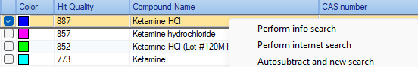Here’s how:

1. Run a spectral match. Hover over match results, right-click and select “Auto-Subtract and new search”.

!!BEWARE!! Auto-subtraction can over-subtract and leave an inverted peak that messes up the next match. It looks like a large dip on the scan (see below).

**TIP** Do a new “Normal Analysis” on the residual spectrum but restrict the search area (uncheck file limits & change search region to exclude the large dip).

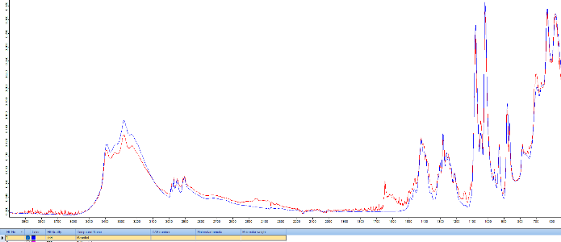

Sample spectrum (red) with a great match to mannitol (blue) as a first hit upon “Normal Analysis”. Mannitol was auto-subtracted and the new residual spectrum (red below) from that subtraction is shown below.

.

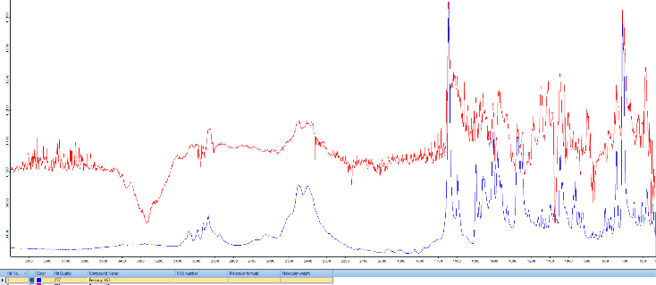

The residual spectrum (red) was a great match to fentanyl HCl (blue) despite the major inversion shown around 3300 cm-1.

2. Consider doing the auto-subtraction more than once to identify all components in a mixture.

The Abbreviated Standard Operating Protocol for Scanning Analysis of Discarded Drug Packaging Detritus from the Massachusetts Drug Supply Data Stream (MADDS) can be found at this [link](https://www.info.streetcheck.org/_files/ugd/1817d1_a46fe6e63c1d4a0581f15ac46033215b.pdf).



**FTIR Analysis Job Aid: “Information Search”**

This document was developed by the Massachusetts Drug Supply Data Stream (MADDS). Our suggested citation for this resource is: Massachusetts Drug Supply Data Stream. (2023, July 14). FTIR Analysis Job Aid. (Massachusetts Drug Supply Data Stream, July 14, 2023). For more information, please visit our website at: streetcheck.org. To get in touch with us, please email: [madds@brandeis.edu](mailto:madds@brandeis.edu).

If you have a hunch you know the component: Compare the sample spectrum to a particular substance using the “Information search” feature. Here’s how:

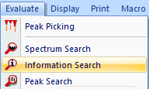

1. Click “Evaluate” → “Information Search” or click on the shortcut button in the toolbox on the right-hand side. It’s a magnifying glass with a lowercase “i” inside.



2. The window that opens has two tabs.

* First tab--the “Information Search,” has a free text entry box to type in a suspected substance. If it’s in one of the libraries selected, a new tab will appear in OPUS with the reference spectrum.
* Second tab is the “Select Libraries” tab and can toggle libraries.

3.Check your hunch: overlay the spectrum you selected with the sample spectrum and have a look. To do this, use the drag and drop function.

**Here’s how:** [**https://vimeo.com/844594023**](https://vimeo.com/844594023)**.**

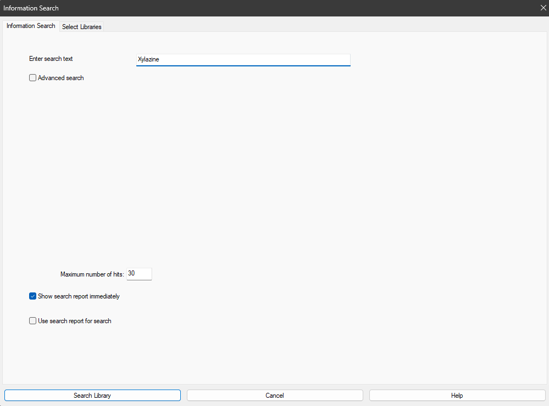

The Abbreviated Standard Operating Protocol for Scanning Analysis of Discarded Drug Packaging Detritus from the Massachusetts Drug Supply Data Stream (MADDS) can be found at this [link](https://www.info.streetcheck.org/_files/ugd/1817d1_a46fe6e63c1d4a0581f15ac46033215b.pdf).



**FTIR Analysis Job Aid: Mixture Analysis**

This document was developed by the Massachusetts Drug Supply Data Stream (MADDS). Our suggested citation for this resource is: Massachusetts Drug Supply Data Stream. (2023, July 14). FTIR Analysis Job Aid. (Massachusetts Drug Supply Data Stream, July 14, 2023). For more information, please visit our website at: streetcheck.org. To get in touch with us, please email: [madds@brandeis.edu](mailto:madds@brandeis.edu).

Think it’s a mixture? Run a mixture analysis. Here’s how:

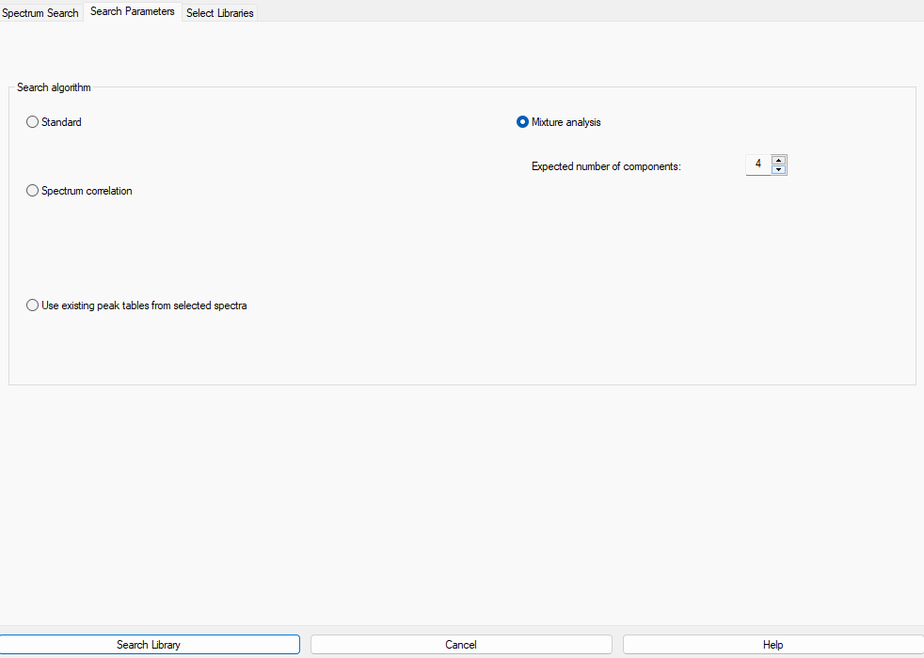

1. Click “Spectrum Search.”

2. In the spectrum search window, go to the second tab “Search Parameters” and pick “Mixture Analysis.” Adjust the number of expected components in the sample (minimum 2, maximum 10). Base this # on all the info you have and your expertise.

1. Click “Spectrum Search.”

3. Click “Search Library” in the bottom left.

Because this is a “best estimate” to a combo of the spectra based on the # input, results are a probability (hit quality of composite spectrum). The results give a percentage make-up of the substance in the spectrum.

4. If matches for the composite spectrum are poor, run it again but shift the # of expected substances up or down and re-run mixture analysis. If still poor matches, the mixture might be too complex for OPUS and the mixture analysis feature may not be a useful tool for analysis.

5. Check the residual spectrum from the mixture analysis for any peaks that remain unaccounted for and need attention! There’s not much you can do if peaks remain—this is a limitation of mixture analysis. There are many limitations to mixture analysis, so be aware of the tools and what they can/not tell you.

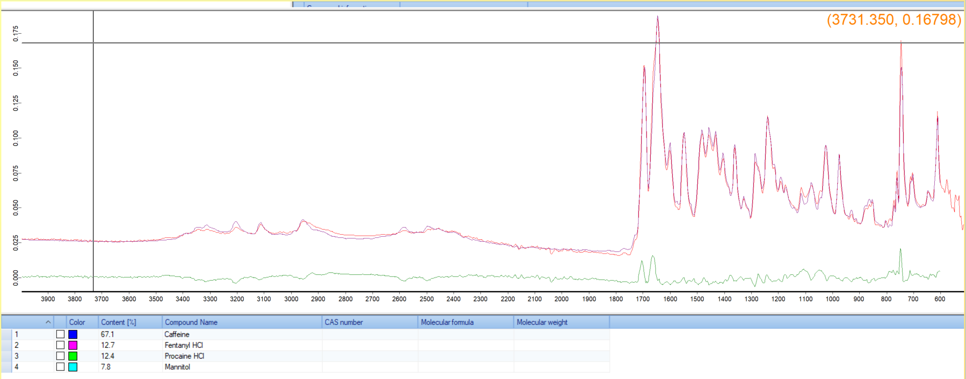

[*Mixture Analysis Example 1*](https://drive.google.com/file/d/1sCajISQCHgV1YBbJyR_Kvriiixe_L_gV/view?usp=drive_link)

The sample spectrum (red) matches very well to the composite spectrum (purple) that was provided via mixture analysis with residual spectrum (green).

The Abbreviated Standard Operating Protocol for Scanning Analysis of Discarded Drug Packaging Detritus from the Massachusetts Drug Supply Data Stream (MADDS) can be found at this [link](https://www.info.streetcheck.org/_files/ugd/1817d1_a46fe6e63c1d4a0581f15ac46033215b.pdf).



**FTIR Analysis Job Aid: Additional Items & Notes**

This document was developed by the Massachusetts Drug Supply Data Stream (MADDS). Our suggested citation for this resource is: Massachusetts Drug Supply Data Stream. (2023, July 14). FTIR Analysis Job Aid. (Massachusetts Drug Supply Data Stream, July 14, 2023). For more information, please visit our website at: streetcheck.org. To get in touch with us, please email: [madds@brandeis.edu](mailto:madds@brandeis.edu).

**Additional Items/Things to Note:**

**Libraries:**

Still seeing peaks remaining? Think it’s more than noise? Try a different library!

**Stacking:**

When there are multiple components, you may see **stacking**. Stacking causes the peak of the sample spectrum at one location to increase in height to account for >1 substance that is contributing to the absorption of the light at that particular wavelength. For example, caffeine and fentanyl both have peaks in their library reference spectrum around the 1640 cm-1 region.

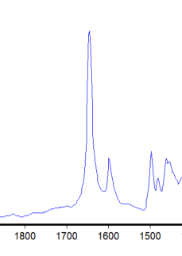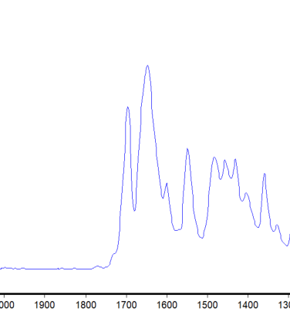

←Fentanyl Library Standard

Caffeine Library Standard →

[Both spectra zoomed in on ~1800-1500 region]

See Below: Sample spectrum (red) having caffeine (blue) and fentanyl (black) stacking across the spectrum [Spectrum zoomed in from ~1800-700]. Note the sharp peak on the sample spectrum at 1640 is sharper than the caffeine library standard peak at 1640 indicating the presence of fentanyl.

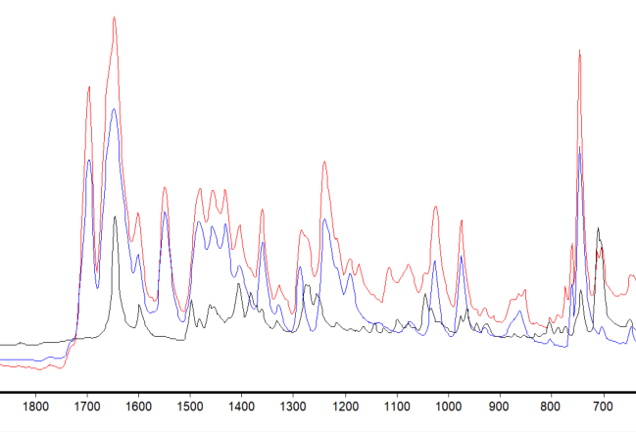

Shifting:

Shifting is when an entire sample spectrum is slightly shifted when compared to a library reference scan.

This can result in a spectrum looking extremely similar to a reference spectrum but will not match perfectly as the location of the peaks on the sample spectrum do not match the library spectrum. Shifting is typically easily accounted for in a single substance sample but can be made more difficult in a mixture.

Example of a sample spectrum (red) shifted slightly relative to the cocaine HCl (blue) reference spectrum. The peaks in the red sample spectrum match perfectly along the spectrum but there is a shifting of the entire sample spectrum to the left. The hit quality is much lower than expected as well since the location of the peaks is critical to the matching algorithm.

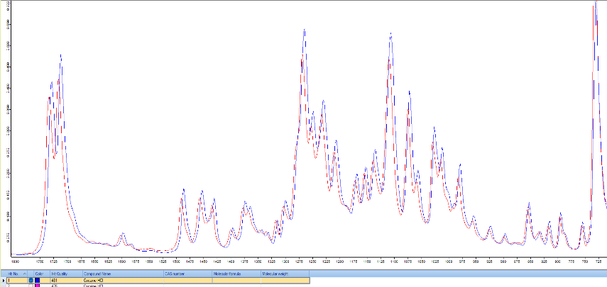

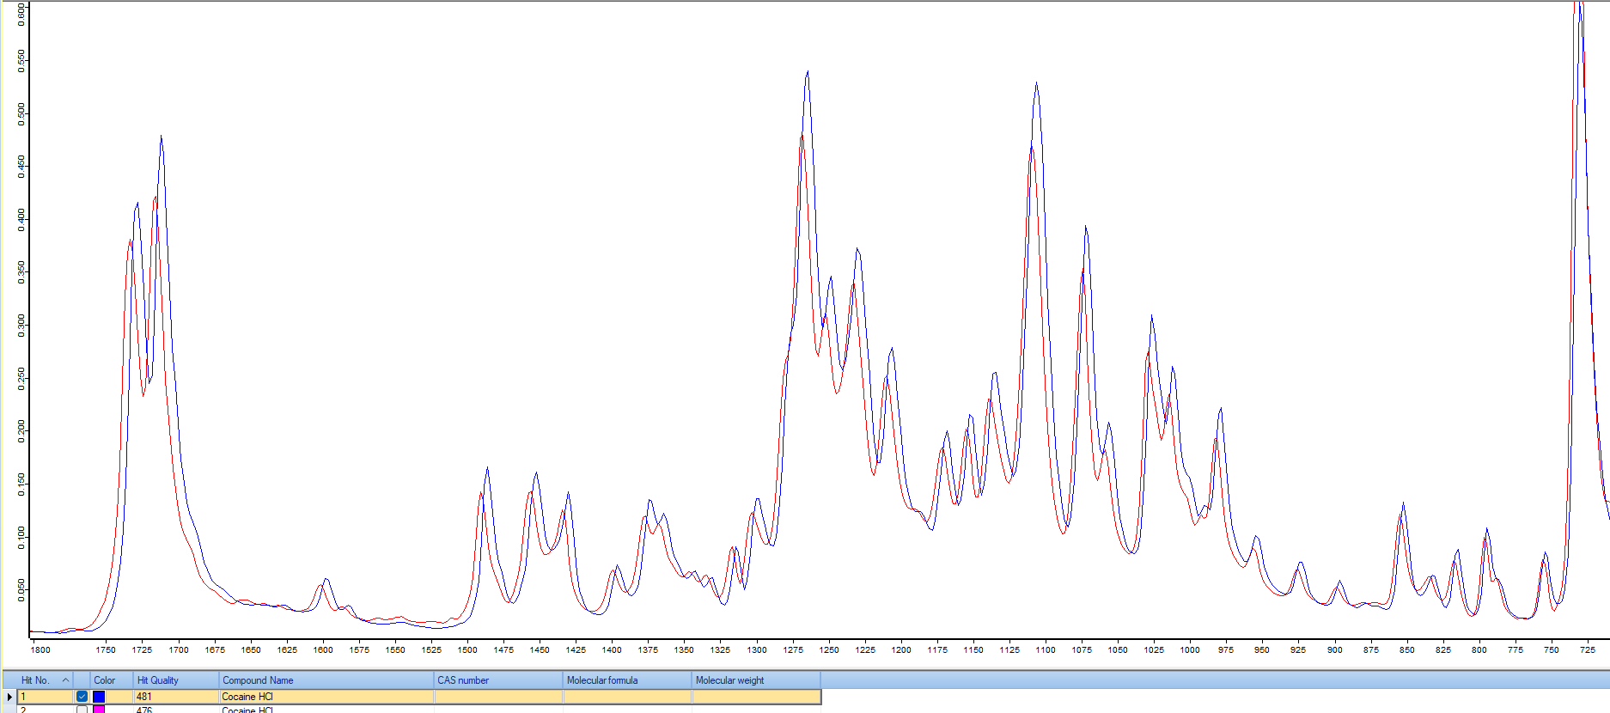The Abbreviated Standard Operating Protocol for Scanning Analysis of Discarded Drug Packaging Detritus from the Massachusetts Drug Supply Data Stream (MADDS) can be found at this [link](https://www.info.streetcheck.org/_files/ugd/1817d1_a46fe6e63c1d4a0581f15ac46033215b.pdf).