This document is meant to serve as a guide for sending samples through the mail to our partner laboratories. Please note that some of the directions and guidelines are new.

It is best to **batch** samples together when mailing for a number of reasons (i.e. fewer trips to the post office, less parcels for the lab to open, etc.). Store all samples collected within an allotted time span in a locking bag (once a week is recommended but dependent on volume). Find a recurring time to mail once enough samples have been collected. Find a system/timeline that works best for you and your organization!

Individual envelopes containing samples of interest or priority are still able to be mailed off to the lab alone/as an individual envelope with proper stampage. If you have a sample you would like to flag for faster laboratory testing, please mark it in StreetCheck unger “Flags” and adhere the “Sample Flagged for Faster Laboratory Testing” sticker to the mylar bag. This is the most efficient way to let the lab know this sample is of priority and needs to be moved to the front of the testing queue. Let the MADDS team know if you need an Avery sticker sheet of the faster lab testing stickers.

**Please be sure there is only one sample / sample bag in one mylar bag**. If you are going to send more than one inflexible item (cooker, pipe, container), use a padded envelope or box. If you are mailing more than 5 cookers or other containers, use a box. If a box has a lot of empty space, add bubble wrap to prevent the envelopes/samples from bashing against the sides of the box (particularly for pipe/glass samples). See the table below for more information.

Make sure each sample sent to the lab is labeled with a Sample Identifier (Sample ID) AND a Lab Code. **If you are not sending the sample ID bag to the lab please write the sample ID on the mylar bag.** This ensures the lab results will be matched and uploaded to the proper sample.

**General Mailing Best Practices**

**DO’s:**

* Add samples in their sample ID bag directly into the lab coded mylar bag
  + No need to remove the sample from the sample bag - just insert the sample ID bag into the lab coded mylar bag
* If batching, you do not need to squish/compress the cooker
  + The cooker still needs to fit into the mylar bag so please ensure it is packaged properly
* When sending samples in a box/padded envelope, you can put multiple mylars in a ziplock bag in the package.
* If sending a sample off for quantification, add the sample to a microcentrifuge tube or a Brandeis branded wax fold glassine bag before adding to the sample bag.

**DON’Ts:**

* Do not put your or your organization’s address as the return address. Put the laboratory’s address as the return address as well as the ‘mail to’ address.
* Do not leave the sample outside of the mylar bag - critical for safety
  + We do not want sample bags destroyed by USPS - the mylar bag protects the sample and the folks handling the envelope
* Do not send multiple samples within one mylar bag. One sample per sample bag, in one lab coded mylar bag.
* Do not send TOO much sample to the lab. The lab only needs a small amount of sample, never more than 50 mg.
  + Special case for pills - send the entire pill/all contents of the crushed pill to the lab

**How to Mail Samples to External Lab Partners - Updated Oct. 2024**

|  |  |  |  |
| --- | --- | --- | --- |
| **Form or materials of the sample** | **Mail**  **Packaging** | **Mailing Directions** | **Notes** |
| Baggie | White Envelope (not padded) | One stamp is sufficient. Can mail in blue box or at post office. | **Procedure for priority sample. Adhere Faster Lab Testing sticker to mylar bag.** If not a priority sample, batch into a box/padded envelope. |
| Container  (Plastic vial, small metal container, etc.) | Padded envelope | Place all samples in their individual mylars in a ziplock baggie. Add to a padded envelope. Seal, address, bring to the post office and mail at the service desk. | It is best to add multiple items to a padded envelope! If heavier, shift to a box. |
| 1 Cooker  More than 1 Cooker | Envelope with cooker wrapped in bubble wrap  Padded envelope or box. | Seal and bring to the post office to get weighed and mailed.  Place all samples in their individual and labeled mylars in a ziplock baggie. Add to a padded envelope, seal, address, and bring to the post office. Mail at the service desk. | **Not a recommended procedure unless a priority sample.**  Please batch and add to a padded envelope or box.  It is best to add multiple items to a padded envelope! Typically do not add more than 5 items in a padded envelope. If items are heavier or if you have multiple cookers (>5), use a box. |
| Pipe | Box or padded envelope wrapped in bubble wrap | Place all other samples from that day (in individual mylar bags) into a ziplock bag. Add to a box or padded envelope. Seal with packing tape, address, and bring to the post office and mail at service desk. | It is best to add multiple items to a box! Please add bubble wrap to the empty space to prevent broken glass arriving at the lab. |

If you have any questions on proper mailing procedures or if you if you need any supplies such as boxes, padded envelopes, bubble wrap, etc. please contact Shannon/Abby:

[shannonraeke@brandeis.edu](mailto:shannonraeke@brandeis.edu)

abbyedelmann@brandeis.edu

**Batch Shipping DC Samples through USPS:**

1. Please take a look at the following link and decide how many boxes you would like to have on hand: [USPS Forever Prepaid Small Box Details](https://store.usps.com/store/product/shipping-supplies/priority-mail-forever-prepaid-small-box-P_PPSFRB#moreinfofooter) 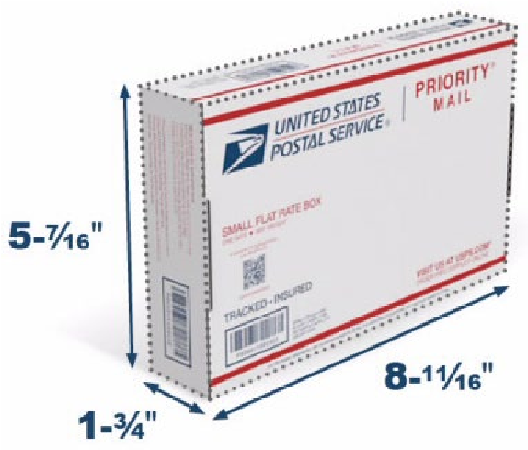

1. Please email Shannon Raeke at shannonraeke@brandeis.edu and write a request with the following information: number of boxes needed (minimum is 10) and for which lab(s), address, and any shipping instructions (ex. ATTN information or mail carrier directions).**

1. Once you have received your shipment of boxes you will notice that it has your chosen lab on the return labels:

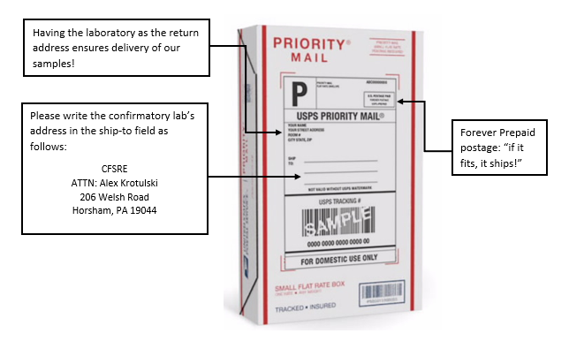

1. When packaging drug checking materials for shipping, please follow the latest StreetCheck’s guidelines for packaging and mailing samples to external labs. This guide was developed by the MADDS Team to provide guidance on sending samples to external lab partners.

1. In addition to the standard packaging instructions, please place all of the mylar-bagged samples in a larger plastic bag (i.e. gallon bag) for added protection.

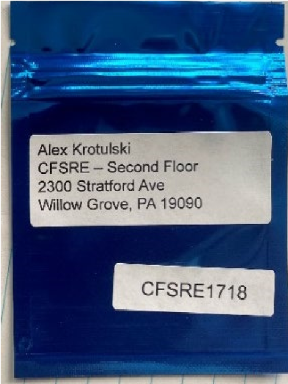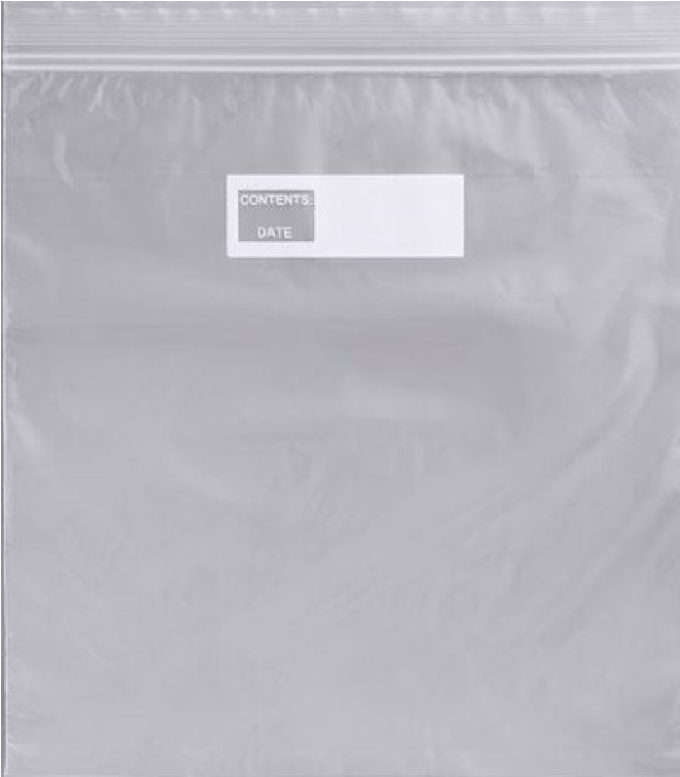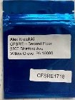

1. Once properly packaged, please bring to closest post office to ship. You should not be asked to pay an additional cost for shipping. If you encounter any issues that require reimbursement, please contact Shannon Raeke at shannonraeke@brandeis.edu or call (774)-454-7130 for more immediate assistance.

1. You will receive a receipt with tracking information available for your reference. Thank you for all you do for the communities you serve!

** **A note about shipping:** Please be advised that upon ordering shipping boxes, USPS allows for 3-5 business day to ship out supplies and another 3-5 business days for supplies to reach their destination. Please consider ordering in larger quantities and reaching out for a new order 2-3 week prior to running out of supplies. Thank you for your patience and cooperation!

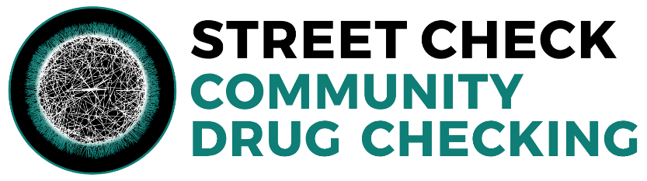

For more information about drug checking resources about community drug checking and additional resources, please visit [the StreetCheck website.](https://www.info.streetcheck.org/)